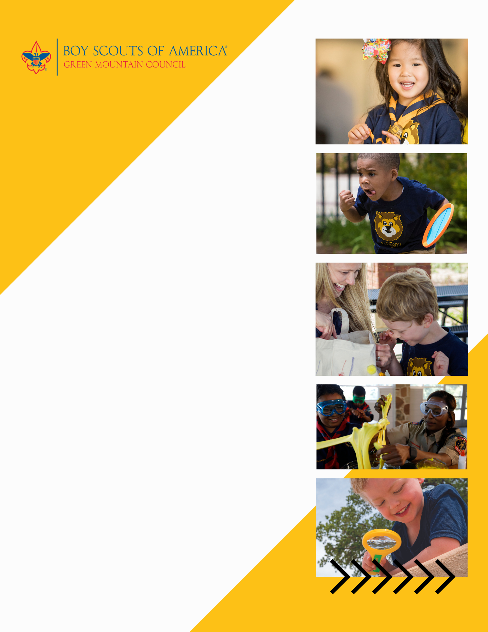

**When:** Saturday May 21 from 11AM-noon

**Where:** Community Playground - 35 Main Street, Barre

**Contact:** Robert Smith

pack123@gmail.com

(802) 345-6029

………………………………….

**Cub Scouting is a year-round program uniquely designed to meet the needs of young boys and girls and their families. The program offers fun and challenging activities that promote character development and physical fitness. Cub Scouting helps parents make the most of the time they have to impact the lives of their children.**

Can’t make it? Learn More About Us at scoutingvermont.org

**Woodstock pack 123**

**invites all K-5th grade boys and girls**

**to join in the FUN!**

**Special joining event for youth entering Kindergarten and 1st grade in the fall. Everyone is welcome!**

**Join your Pack at beascout.scouting.org**