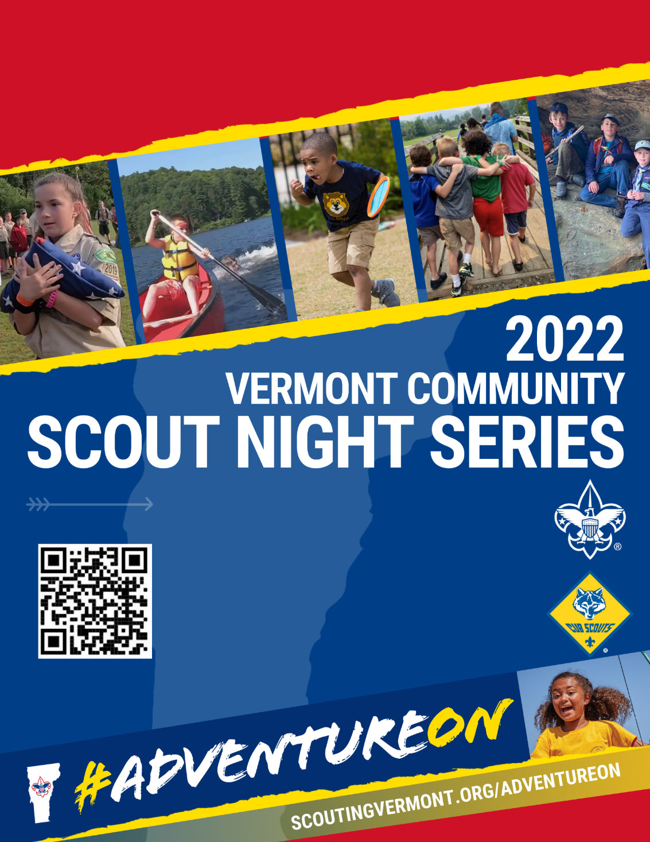

**DATE AND TIME OF EVENT HERE**

**LOCATION HERE**

LOCATION ADDRESS GOES HERE

Contact INFO HERE

Contact INFO HERE

**DATE AND TIME OF EVENT HERE**

**LOCATION HERE**

LOCATION ADDRESS GOES HERE

Contact INFO HERE

Contact INFO HERE

Want your 5–17 year old to grow in confidence, be a goal-getter, and gain a passion for the outdoors?

Join the program that will prepare

your child for life!

Want your 5–17 year old to grow in confidence, be a goal-getter, and gain a passion for the outdoors?

Join the program that will prepare

your child for life!