Ensure a happy holiday parade with these

15 safety tips – for Troops and Packs

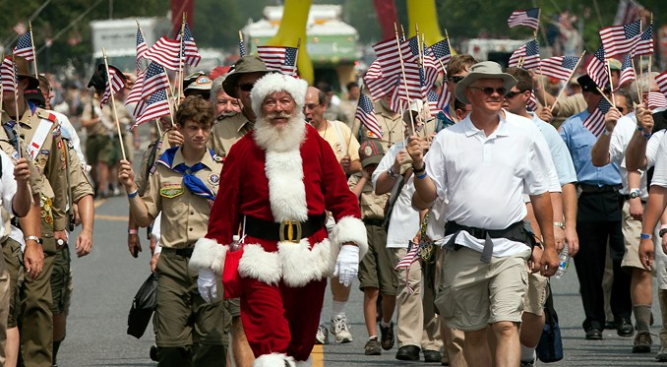
Marching in a holiday parade with your Scouts this year?
Keeping everyone safe should be tops on your wish list. After all, nothing can ruin the holidays quicker than a sprained ankle or broken arm — or worse — a few days before winter break.
Included in the 15 are some tips you might not have known, like this one: Scouts should walk along the route or ride in passenger cars (assuming two-deep leadership).
They may ride on floats, truck beds, trailers or the like, but only if they follow the rules in No. 7 below.
All it takes is one Scout getting injured for you to understand why these rules exist. Is it worth the risk?
Below are the 15 tips:

1. Have qualified supervision
Do you have enough adults to supervise Scouts and monitor for hazards along the route?
Many packs and troops use a four-corners approach with adults: two adults at the front — left and right — and two bringing up the rear.

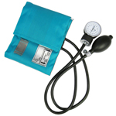

2. Consider physical fitness
How long is the parade route?
Are there hills?
Adults and youth need to be in good enough shape for the length and conditions.

3. Use the buddy system
Before you begin the march, make sure each Scout — and adult! — has a buddy.
That’s especially important in crowded environments.
Parades are typically crowded, and you don’t want a Scout to get lost in the shuffle.

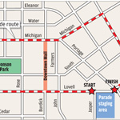

4. Find a safe area
You wouldn’t choose a busy street for a Scout activity, but you don’t get to pick the location of a parade.
Parades can bring risks that might not ordinarily be present:
- Moving vehicles and machinery
- Animals
- Firearms or fireworks
- Hazardous weather
- Large or unruly crowds
- Potential for thrown objects

5. Check vehicles used to transport Scouts
Any vehicle used for transporting passengers should be equipped with a secure passenger compartment and approved safety belts.
And don’t put more people in a passenger vehicle than it’s designed to hold.
See No. 7, below, for more on Scouts and parade vehicles.

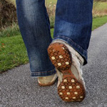

6. Bring personal safety equipment
Dress for the weather, and bring the following:
- First aid kit (one or two per unit should suffice)
- Rain gear
- Good walking shoes
- Water bottle
- Sunblock
- Insect repellant

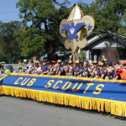

7. Follow proper safety procedures
- Allow adequate space between marchers and any vehicles
- Designate a lookout to watch out for vehicles and other hazards
- Take head counts before, during and after the parade
The BSA rule prohibiting the transportation of passengers in the backs of trucks or on trailers may be tempered for parade floats or hayrides, provided that the following points are strictly followed to prevent injuries:
- Transportation to and from the parade or hayride site is not allowed on the truck or trailer.
- Those persons riding, whether seated or standing, must be able to hold on to something stationary.
- Legs should not hang over the side.
- Flashing lights must illuminate a vehicle used for a hayride after dark, or the vehicle must be followed by a vehicle with flashing lights.

8. Consider the abilities of younger and older members
If the forecast calls for unseasonably warm or cold weather where you live, don’t be afraid to suggest that your younger Cub Scouts or older adults find a seat on the sidelines.
Perhaps they could find a better way to participate that’s suited to them.
Better safe than sorry.

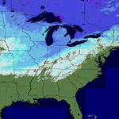

9. Watch the weather
Don’t let a blizzard, high winds or rain make your parade dangerous.
Check the forecast several days out and daily as the parade approaches.
The best outcome in weather emergencies is to avoid them altogether.

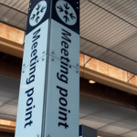

10. Plan ahead
Do you have all of your permission slips?
Did you determine a meeting spot for before and after the parade?
Did you distribute maps and emergency cellphone numbers to the adults?
Hold a pre-parade meeting with adult leaders where you discuss these items, consider severe-weather locations and discuss the location of a support vehicle nearby.

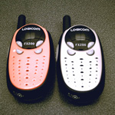

11. Secure a communication plan
Cellphones or two-way radios can keep everyone on the same page.
You can use them in emergencies, of course, but also to tell parents and families when you’re nearing their spot along the parade route.
If you’re using cellphones, make sure you have numbers pre-programmed into your phone. With radios, find an open channel and stick to it.

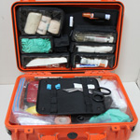

12. Bring a first aid kit
Have first aid supplies handy.
Have trained adults who know first aid.
Find out what resources will be available at the parade, where they will be located and how to contact them if needed.

13. Follow applicable laws
Know and follow all parade rules and regulations.
Most community parades have rules that they distribute to all participants.
Be sure to read them carefully.

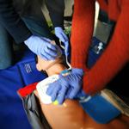

14. Bring a CPR-trained adult
Will there be firemen, EMT professionals and CPR-trained police officers all along the parade route?
Probably.
Should you have a CPR-trained adult with your group anyway?
Absolutely.

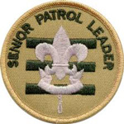

15. Promote discipline
An essential part of parade safety is discipline. That means reminding Scouts that marching in the parade is a privilege.
They’re representing the entire Scouting organization to the community.
If you’re a Cub Scout pack, you can have that talk with the boys. If you’re a troop, ask your senior patrol leader to lead the talk.

