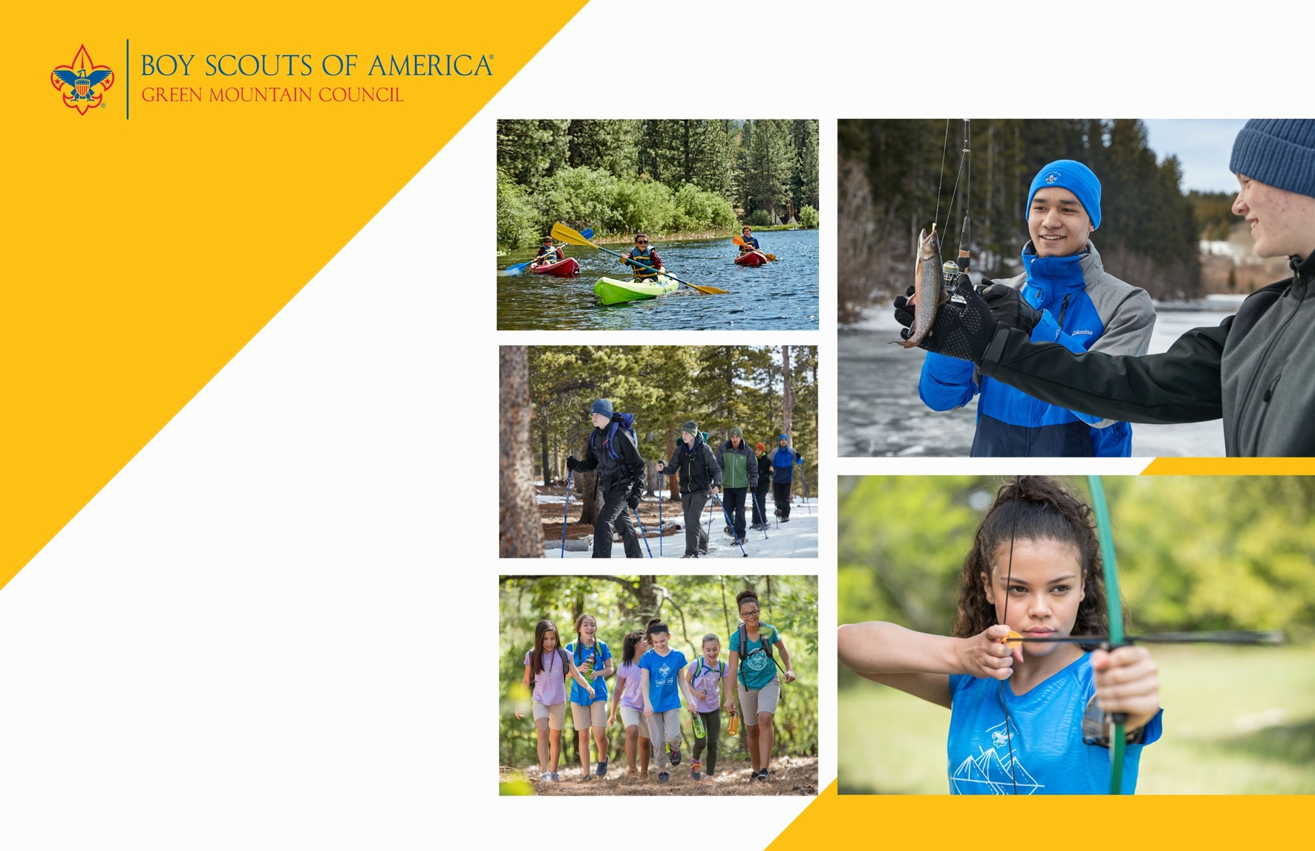



**Woodstock**

**Troop 123**

**invites all youth**

**11-17 years old**

**to join in the ADVENTURE!**

**Woodstock**

**Troop 123**

**invites all youth**

**11-17 years old**

**to join in the ADVENTURE!**

**When:** every Sunday at 5:30PM

**Where:** Barre Congregational Church - 35 Church Street, Barre, VT 05641

**Contact:** Robert Smith

scoutroop123@gmail.com

(802) 345-6029

**Join Troop 123 at beascout.scouting.org**

**or contact Robert Smith at troopemail123@gmail.com**

**…………………………………………………………….…………**

**Scouts BSA is the Scouting experience for youth in the fifth grade through high school. Service, community engagement and leadership development become increasingly important parts of the program as youth lead their own activities.**

Can’t make it? Lear more about us at scoutingvermont.org



**…………………………………………………………….…………**

**Scouts BSA is the Scouting experience for youth in the fifth grade through high school. Service, community engagement and leadership development become increasingly important parts of the program as youth lead their own activities.**

Can’t make it? Lear more about us at scoutingvermont.org

**Join Troop 123 at beascout.scouting.org**

**or contact Robert Smith at troopemail123@gmail.com**

**When:** every Sunday at 5:30PM

**Where:** Barre Congregational Church - 35 Church Street, Barre, VT 05641

**Contact:** Robert Smith

scoutroop123@gmail.com

(802) 345-6029

**Cub Scouting is a year-round program uniquely designed to meet the needs of young boys and girls and their families. The program offers fun and challenging activities that promote character development and physical fitness. Cub Scouting helps parents make the most of the time they have to impact the lives of their children.**