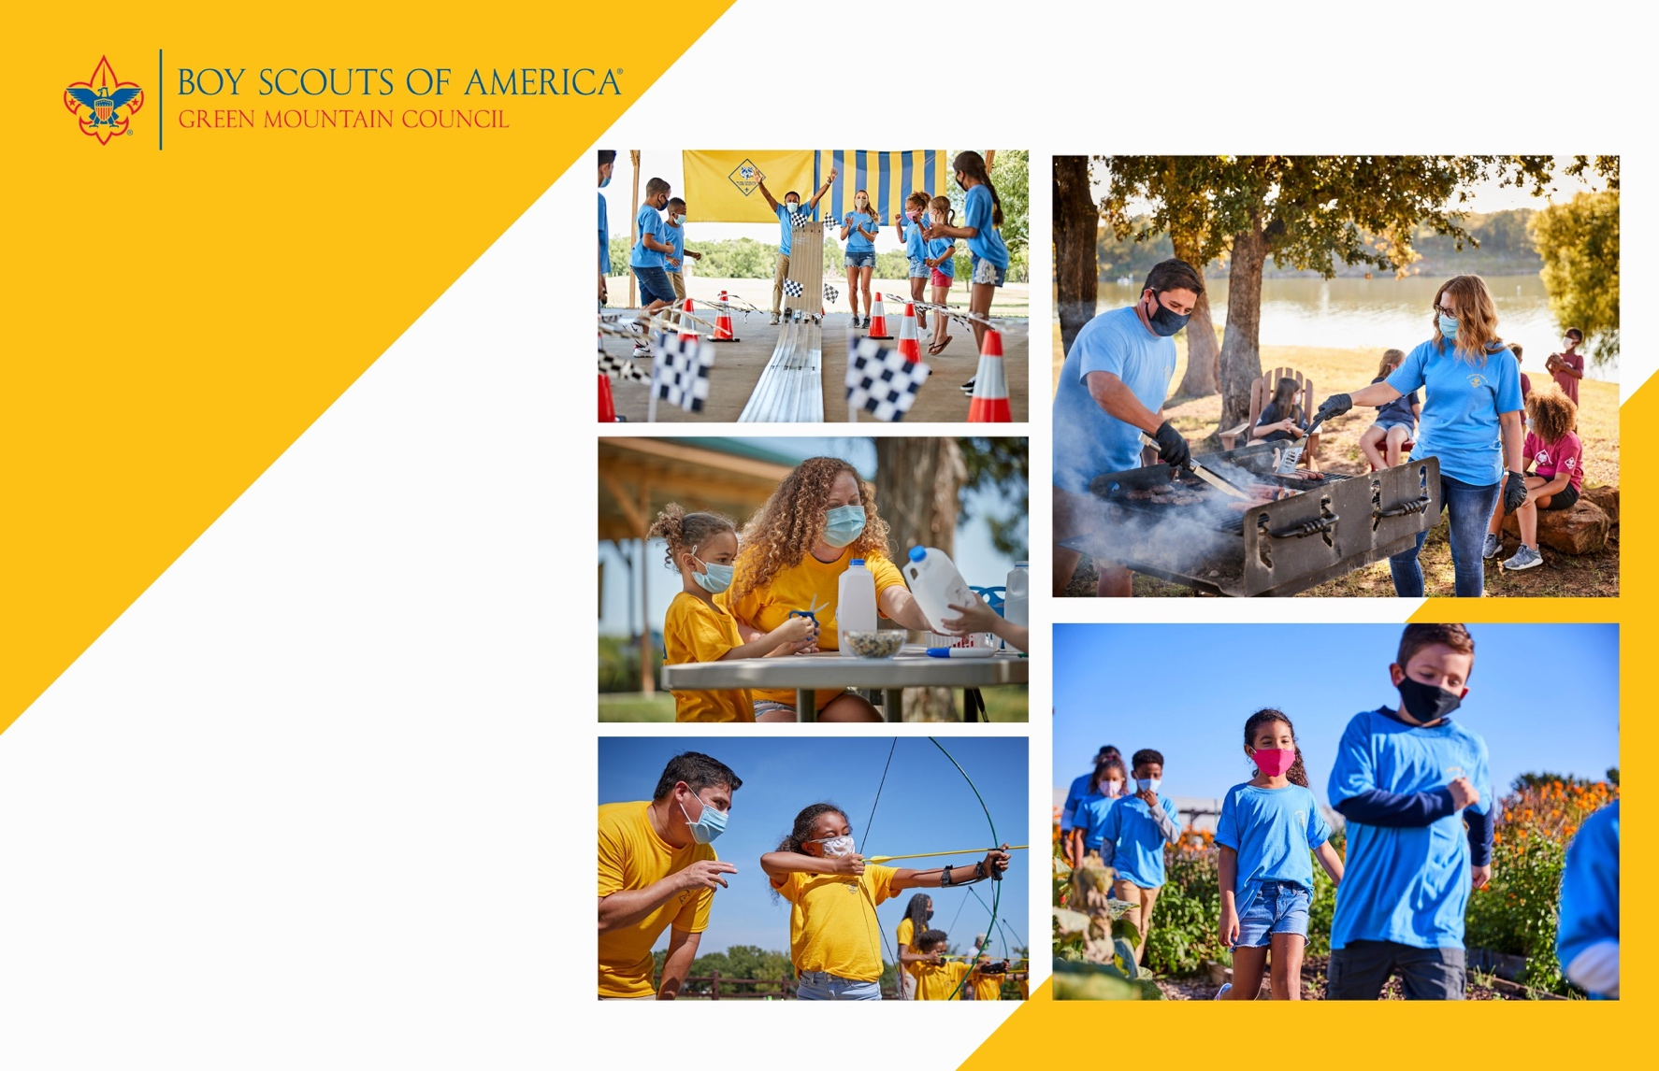



**Woodstock**

**pack 123**

**invites all K-5th grade boys and girls**

**to join in the FUN!**

**Woodstock**

**pack 123**

**invites all K-5th grade boys and girls**

**to join in the FUN!**

**…………………………………………………..……**

**Cub Scouting is a year-round program uniquely designed to meet the needs of young boys and girls and their families. The program offers fun and challenging activities that promote character development and physical fitness. Cub Scouting helps parents make the most of the time they have to impact the lives of their children.**

Can’t make it? Lear more about us at scoutingvermont.org

**Join Pack 123 at beascout.scouting.org**

**or contact Robert Smith at Cubscoutpack123@gmail.com**

**When:** every 2nd Sunday of the month

at 5:30PM

**Where:** Barre Congregational Church - 35 Church Street, Barre, VT 05641

**Contact:** Robert Smith

Cubscoutpack123@gmail.com

(802) 345-6029



**…………………………………………………..……**

**Cub Scouting is a year-round program uniquely designed to meet the needs of young boys and girls and their families. The program offers fun and challenging activities that promote character development and physical fitness. Cub Scouting helps parents make the most of the time they have to impact the lives of their children.**

Can’t make it? Lear more about us at scoutingvermont.org

**Join Pack 123 at beascout.scouting.org**

**or contact Robert Smith at Cubscoutpack123@gmail.com**

**When:** every 2nd Sunday of the month

at 5:30PM

**Where:** Barre Congregational Church - 35 Church Street, Barre, VT 05641

**Contact:** Robert Smith

Cubscoutpack123@gmail.com

(802) 345-6029

**Cub Scouting is a year-round program uniquely designed to meet the needs of young boys and girls and their families. The program offers fun and challenging activities that promote character development and physical fitness. Cub Scouting helps parents make the most of the time they have to impact the lives of their children.**