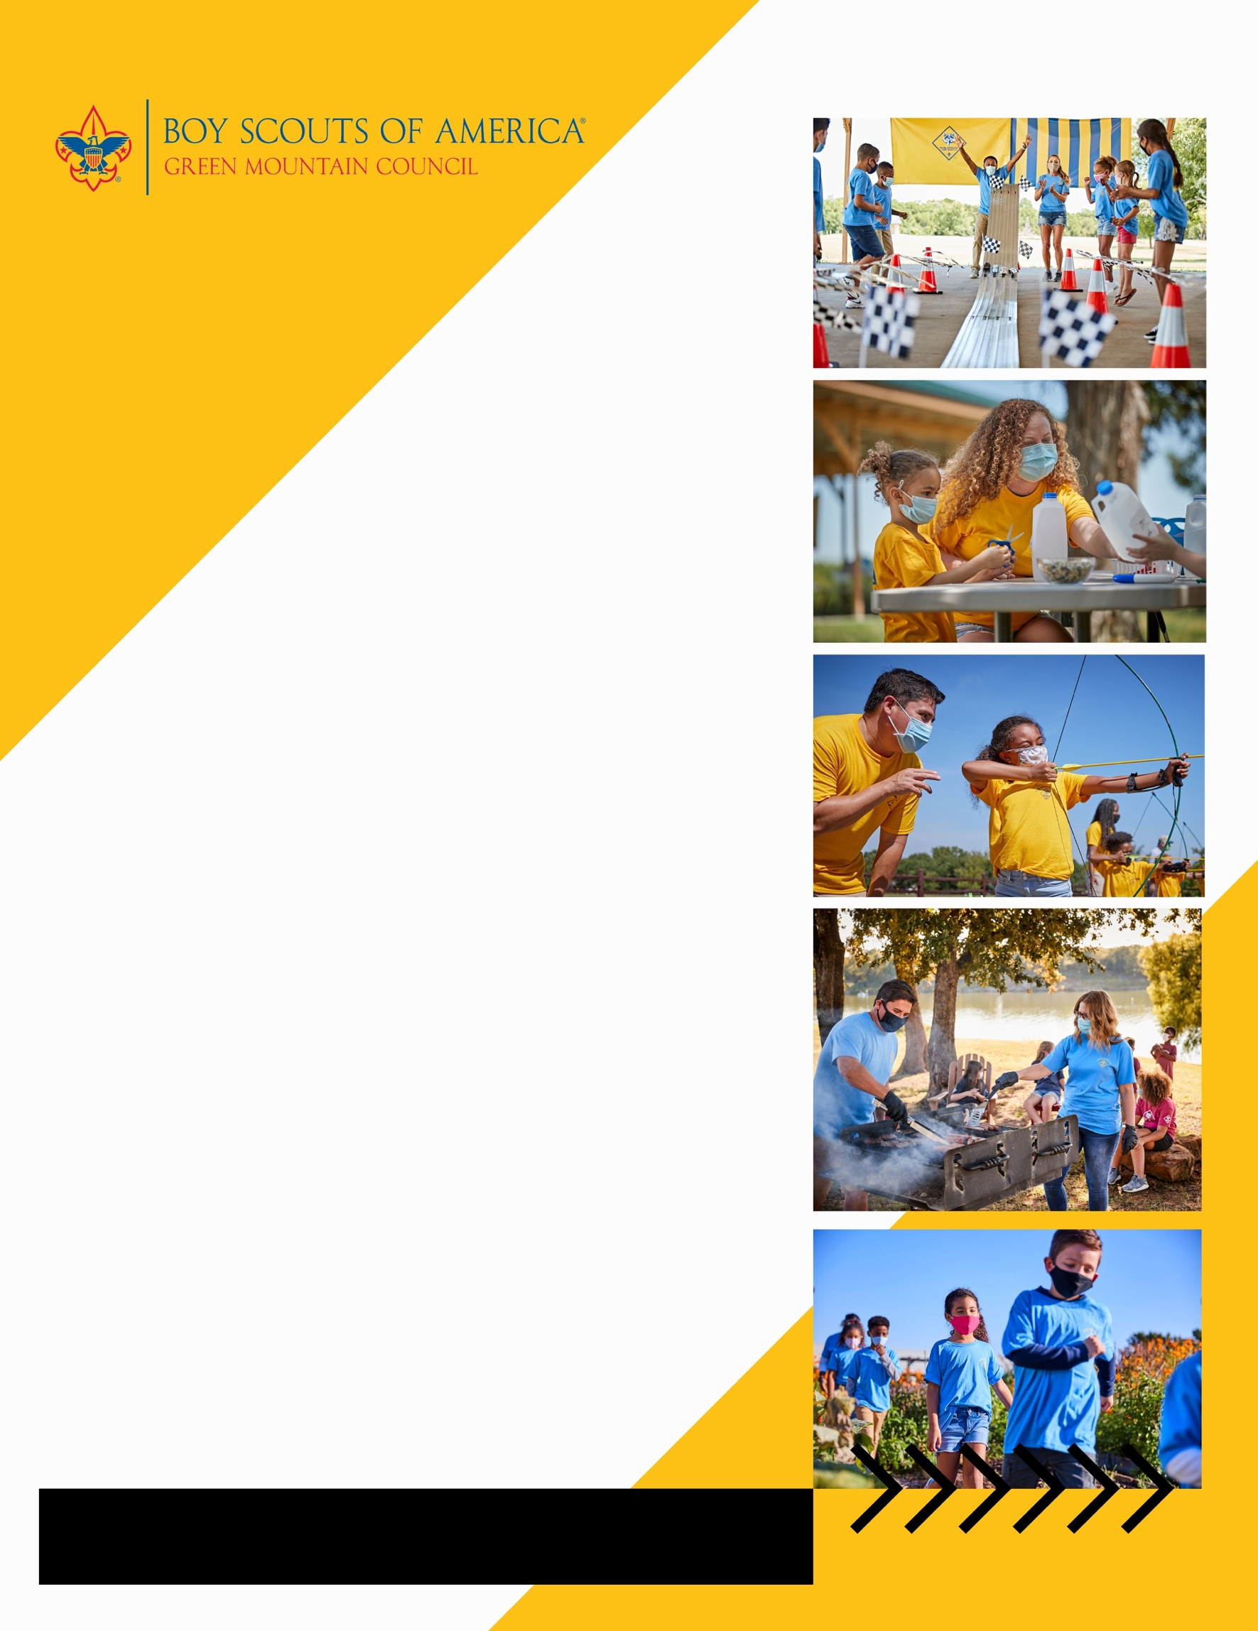

**Join your Pack at beascout.scouting.org**

**Cub Scouting is a year-round program uniquely designed to meet the needs of young boys and girls and their families. The program offers fun and challenging activities that promote character development and physical fitness. Cub Scouting helps parents make the most of the time they have to impact the lives of their children.**

Can’t make it? Learn More About Us at scoutingvermont.org

**When:** every 2nd Sunday of the month

at 5:30PM

**Where:** Barre Congregational Church - 35 Church Street, Barre, VT 05641

**Contact:** Robert Smith

pack123@gmail.com

(802) 345-6029

…………………………………

**Woodstock pack 123**

**invites all K-5th grade boys and girls**

**to join in the FUN!**