101 Great Scout Service Project Ideas for Troops and Packs

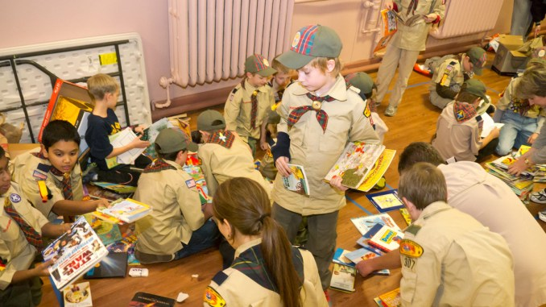
Nothing your Scout unit can do raises community awareness more than a service project.
These good turns are some of our best marketing tools. They send the message that Scouts are here, making life better for others.
But where to start? We have collected 101 Scout service project ideas below. These should get you started, but really anything that fulfills a community need (and follows the BSA’s Guide to Safe Scouting) can count for service hours.
Here’s the list for both Packs and Troops!
Note: While some of these might make great Eagle Scout service projects, most are intended for unit-level service.
- Organize a book and magazine drive, with the collected items going to a daycare, overseas soldiers, a VA medical center or an inner-city school
- Help out a local Cub Scout pack at its pinewood derby, Arrow of Light presentation or by teaching camping or cooking skills
- Improve your local Scout summer camp, perhaps by clearing trails, splitting wood, repairing tents or more
- Volunteer at a district event, running the first-aid station or staffing the Klondike derby
- Participate in Scouting for Food, the annual canned-food drive
- Help at the Scout Show, the council-level event where your volunteer service is always welcome
- Lend a hand at University of Scouting, the training event for volunteers, can always use help
- Go caroling at a local nursing home
- Perform skits or songs at a homeless shelter, nursing home or children’s advocacy center
- Collect gifts and make gift baskets for elderly people with no families
- Prepare and distribute holiday cards (Valentine’s Day, Christmas, etc.) for people without families of their own
- Assist in snow/ice removal for members of the community or businesses that need a hand
- Assist in yard work for members of the community or businesses that need a hand
- Adopt a needy family
- Help agencies cook and serve meals for the homeless
- Make gift boxes to be distributed by a local charity
- Stock shelves at a local food pantry
- Place flags on gravesites for Memorial Day or other special days of remembrance
- Create and deliver thank-you cards to veterans on Veterans Day (or any day)
- Help religious organizations set up religious exhibits or activities
- Deliver, retrieve and dispose of Christmas trees
- Help residents set up or take down Christmas lights
- Repair and paint holiday decorations
- Collect toys for Toys for Tots (or a local equivalent)
- Prepare and serve hot chocolate or apple cider at the annual town tree-lighting ceremony
- Purchase and distribute toys for the children’s hospital near you
- Make stuffed animals, such as a Build-a-Bear, to brighten up a child’s holidays
- Assist with parking cars at a local event (but please follow strict safety protocols!)
- Assemble Easter baskets and distribute to local shelters
- Provide free coffee at rest stops on heavy travel weekends, such as Thanksgiving or Memorial Day
- Help run a fall carnival or pumpkin patch
- Create or help create and run a haunted house
- Assist at alternative trick-or-treat events
- Adopt a town after a disaster
- Assist organizations that provide home maintenance service
- Help paint a school, church or chartered organization
- Clean a Habitat for Humanity house before the family moves in
- Clean a local animal shelter
- Help walk the dogs at the animal shelter
- Perform janitorial duties for your chartered organization
- Repaint fences at government or nonprofit buildings
- Adopt a Highway or road and take care of it
- Take part in a litter cleanup project
- Help beautify city hall
- Clean up and/or help inventory a cemetery
- Clean up and beautify the local community center, campground, park, river or school parking lot
- Clear brush from a fire-prone area
- Improve a town walking trail
- Pick up trash at the chartered organization before or after a meeting (not just the trash you left — check out the entire facility)
- Clean up the shoreline
- Help package medical supplies to be sent to developing countries
- Assist with a blood drive
- Distribute organ donor cards
- Pass out anti-drug literature
- Provide the first-aid station at a district or council event
- Create and distribute first-aid kits to residents in need
- Help children make bicycle safety kits
- Make welcome-home kits for victims of a disaster
- Make bandanas, pillows or other items for cancer patients
- Serve as “victims” for a local first-responders training event
- Adopt a military troop and send them birthday cards and other holiday cards
- Become pen pal with someone serving overseas
- Create video histories of veterans and share the edited results with their families
- Organize a movie night at a VA medical center.
- Send calling cards to servicemen and servicewomen overseas
- Assist in training search and rescue dogs
- Clean and refill bird feeders at the local Audubon Society
- Collect aluminum cans and donate the proceeds to a local charity
- Construct duck houses, owl boxes or birdhouses
- Build an education sandbox for a local nature center
- Build a fence around air conditioners at a local establishment
- Conduct a CPR training event
- Build a handicap ramp at a community location
- As a Boy Scout troop or Venturer crew, offer to cater a pack’s blue and gold banquet
- Run a basketball tournament
- Volunteer at the Special Olympics — water station, handing out medals, etc.
- Construct a soccer field: lines, goals, benches
- Construct bat and helmet racks for your school’s baseball/softball teams
- Build a horseshoe pit at the local park
- Host a dodgeball tournament and donate the proceeds
- Refurbish the press box at a local ballfield
- Serve as volunteer referees or umpires at a sports tournament
- Staff a local run or marathon
- Repair and paint bleachers
- Plant trees
- Hand out voting reminders in the community
- Call residents and encourage them to register to vote
- Conduct a winter coat drive and clean and distribute the coats
- Set up and help run a website or Facebook page for your chartered organization or a local nonprofit
- Perform at a local charity talent show
- Collect unused makeup, perfume and cosmetics for a center for abused women
- Create a poison awareness campaign
- Paint over graffiti (but first check with your city/town government)
- Sponsor a TV blackout event to encourage families to spend time outside
- Host a free camping clinic where you share basic camping skills with residents
- Plant, tend and harvest a vegetable garden and donate what you grow
- Organize a pet show, with a portion of the proceeds going to the winning dogs and the rest going to a local charity
- Design placemats for Meals on Wheels recipients
- Rake leaves for elderly neighbors or your chartered organization
- Lead a game of bingo at a nursing home
- Hold a bike safety rally, where you teach bike skills and inspect the bikes

