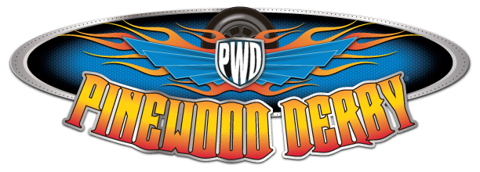

2020 Long Trail District Pinewood Derby Rules
Official Pinewood Derby Rules.
Car Dimension Rules
The overall length of the car shall not exceed 7 inches. The overall width of the car shall not exceed 2 ¾ inches. The car must have 1 ¾” clearance between the wheels. The car must have 3/8” clearance underneath the body so it does not rub on the track.
Derby Car Weight Rules
The car shall not exceed 5.0 ounces. The official race scale that is used at car check-in shall be considered final.
Car Modifications Not Allowed
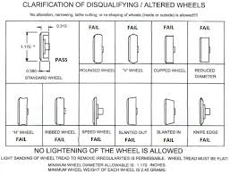
The official pine wood block must be used. The block may be shaped in any way that is desired. Official BSA wheels must be used. The wheels may not be cut, drilled, beveled or rounded. You may remove the seams and imperfections from the wheels. The nails provided in the BSA derby car box are the only approved axles for the District Pinewood Derby. Scouts may polish their axle nails and the only approved lubricant is graphite.

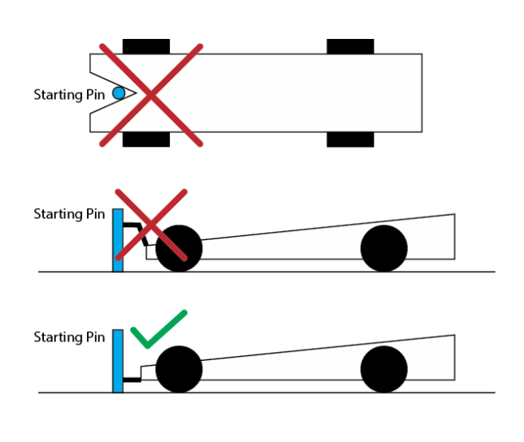
There is no notching the nose of the car the center of the car must be present to rest on the start gate and not damage the timer at the finish line.
Other Pinewood Derby Race Rule.
New for this year! After check in the scout may keep their car with them. At check in the scout will get a VIP name tag. On this VIP tag will be the Scouts name and car number given to them at check in. After check in all Pinewood Derby cars must be inspected at the Tech Inspection Area. Tech Inspector has the responsibility to disqualify those cars that do not meet these rules. If there is any question about a Pinewood Derby car an inspector has the right to inspect the car at any point during the race day. But we want everyone to compete so if you can fix it before the racing starts, we will have a pit area this year. The Pit Area is where there will be some simple tools to fix any cars that may suffer damage during a race or if a scout drops their car and it needs repair. Scouts will need a pit pass that they can get from a track official. In the pit box you will have supervision from Tech officials that may help the scout with repairs if they are available. Once any repair is made the derby car must pass inspection again before racing. Remember a Scout is “Trustworthy”.
Classes and Awards
Lions Top 3 Trophies
Tigers Top 3 Trophies
Wolves Top 3 Trophies
Bears Top 3 Trophies
Webelos/AOL Top 3 Trophies
Adult/Sibling Top 3 Ribbons
Top 3 awards for best in show (car appearance) (Scouts only)
Top 3 awards most unique (Scouts only)
Sportsmanship Award for (Scouts only)
Questions Contact
Christopher Haggett
haggettperformance@yahoo.com

