Survivor Bogaree September 15-17, 2017

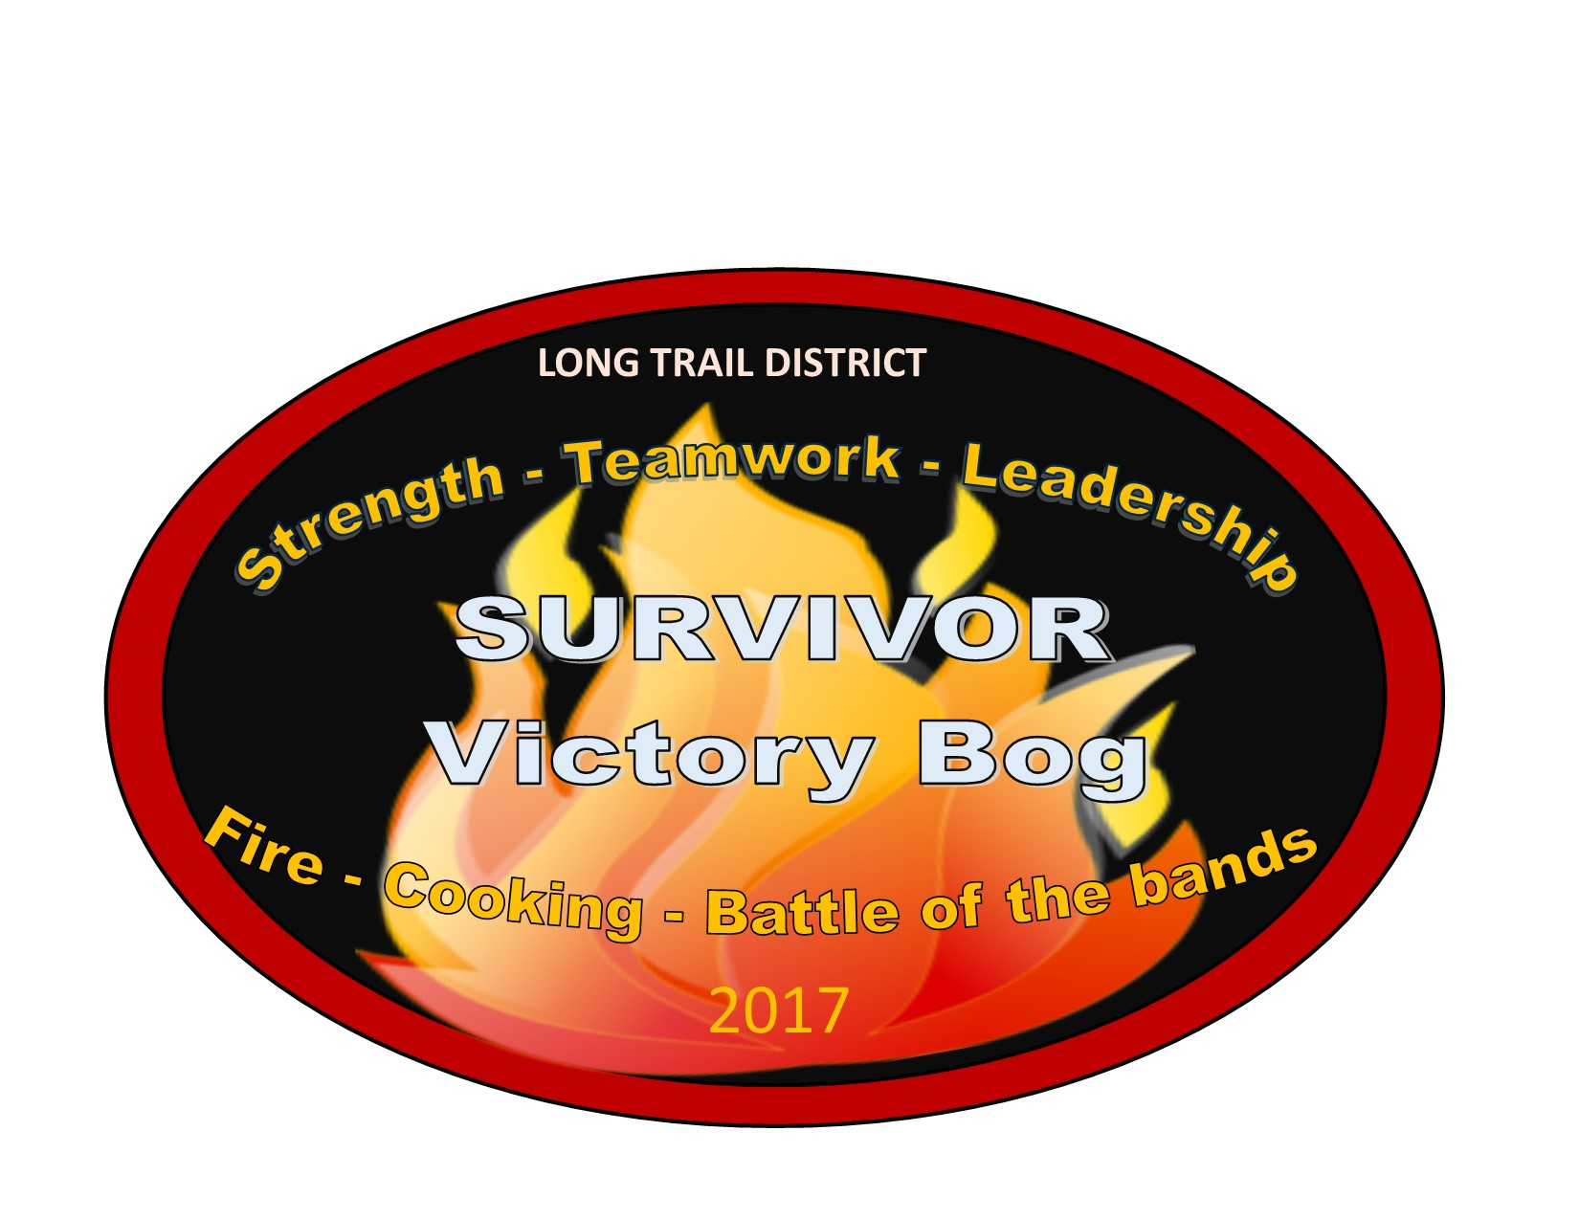
Can you Survive?
IMPORTANT INFORMATION BEFORE CAMP

BEAVER DAY: September 9-10
SATURDAY AND SUNDAY before Bogaree, is Beaver day. This gives Troops a chance to Clean and prepare their campsites if they have a designated Spot. If your troop does not have a reserved spot, don’t worry!! We have PLENTY of space! We can show you some spots for your troop and you can stake your claim!
Items that may help your troop at Beaver Day. (Remember, we do not supply items for clean-up)
Gloves, ear and Eye protection
-Handsaws, bowsaws
- Chain Saws (must have Chainsaw safety course)
- Weed Whackers
-Rakes, Hoes and Shovels

PLEASE REMEMEBER to bring your own Troops Water, we do not supply water and do not have potable water on site. Plan to bring your own water supply.

SURVIVOR CAMP:
In Survivor, teams are recognized by the BUFFS or bandanas they wear. Each member of your Troop should wear matching bandanas to show your troop Pride. Be creative, using colors or designs to have your troop stand out above the rest!
A Survivor Tiki Torch will be provided for your Troop, start thinking how you would like to make it yours!

TRADITIONAL BOG:
Please remember that bog is a wet, dirty, messy event. Not responsible for Scouts returning home covered in mud, soaked socks and smelly. We will however take the credit for Scouts coming out of the bog with Smiles on their faces.
Schedule:
Friday September 15 2017:
4:00 pm: Registration Opens
4:00pm-7:00pm: Campsite set up (Tree Mail)
7:00pm Registration closes (unless prior arrangements made)
8:00pm: Cracker Barrel for Leaders and SPL at Lodge

Saturday September 16 2017
8:00am Opening Ceremonies (Flag, Announcements) (Tree Mail)
8:30am Volunteer meeting at Lodge
9:00am: Morning Activity session Open (see Event Info)
12:00pm Morning Activity session closed
12:00pm-1:30pm Lunch / Free time (Tree Mail)
1:30pm-3:30pm Afternoon Activity Session
3:30pm-6:00pm Free time, troop meal preparation (Tree Mail)
6:00pm-7:00pm Dinner Cooking contest, potluck, dishes to judges
7:30pm Skits, campfire show, awards from day

Sunday September 17, 2017

8:30am Scouts own service
12:00pm all camp sites cleared and cleaned

THANK YOU FOR ATTENDING 2017 BOG

IMPORTANT INFORMATION WHILE AT CAMP
TROOP “TREE MAIL”
All Troops must watch their schedules and check their Own “tree mail” during the events. Clues to upcoming events and Important information will be in their mailbox for limited times only!!
Tribes can check their tree mail at the Lodge. Each Troops box will be clearly labeled.

MEAL CHALLENGE
All Troops will work together to produce a meal for everyone in their troop and a sample to the judges.
Meal must be cooked on site by the Scouts.
Method of cooking (Dutch oven, open fire, Coleman stove, grill, etc) is up to the chef.)
Must Contain surprise ingredient that was chosen at “tribal Council” (Cracker Barrel) The night before, remember, there is always twists to SURVIVOR!!

BATTLE OF THE BANDS
Pick a song that your troop wants to lip sync and air band too! Be ready to perform on the Bogaree Stage for an amazing concert!!! Dress up to add to the pizazz!
No Band can be complete without musical instruments and microphones. We will have some available to use or bring your own! Remember, no singing is actually involved. Dress up to add to the pizazz!
Please submit your song choice ahead of time to avoid repeats and to make sure it is appropriate for all ages.

Morning Activites 9am-12pm

SATURDAY SEPTMEBER 16, 2017
Each Troop will receive Beads for participation of each event. Troop With the most beads will receive the Scoutmaster Award of Survival!

Tug of war: Let’s face it—brute strength is one attribute of a survivor. May the strongest patrols win! Challenge another troop, or your own.
HELP!!! I need somebody: If a member of your patrol is injured in the wilds of The BOG, knowing some basic first aid is essential to your survival!
Quicksand VS. TARZAN: Sometimes island life requires you to face challenges such as quicksand…. See if you can get your troop from sinking
Island Hopping: Your boat is crashed, sharks swimming all around, can you safely get your Troop to the next island??
Coconut Toss: How far can you throw a coconut deep inside the bog? Each Scout will have a chance to throw our “coconut” and see who can throw it the furthest. Prize for Scout who can throw the furthest.
Midnight Land minds: Survival “in the dark” is something you will have to do to navigate through this station. Communication skills are needed to survive. Remember, Survivor always has twists and turns…..
Last Man Standing: Strength, agility and willpower are all factors needed to withstand this challenge. Who knows what the Bog has to throw out at you. Do you have what it takes to be last man standing? Prize for the scout who can stand the longest.
Tomahawk Throwing: Surviving in the wild means hunting your own food, test your aim in the bogs very own Tomahawk Range.

Afternoon Troop Activities

TROOP VS. TROOP Obstacle Course.

Prepare your troop to do a relay style obstacle course ending with fire building.
Flint and steel required to participate in this event.

Running, racing, carrying stuff, up and over around and through! Lots of twists and turns for this course. Not your typical obstacle course, we bring it Survivor Style!!!

For More Information:
Kristy Walker
(802) 274-7089 k_walker333@yahoo.com
Please let me know By September 13, 2017 if your Troop is planning on attending.
Pre-registration is encouraged but not required. We will take walk ins.

