Below, please see a sample press release explained. On the following page, an additional sample press release that you can revise as appropriate and use for your unit is provided.
The additional sample in the following page is about virtual activities during the pandemic, but your press release could be about anything that you unit wants to promote: a community service project, a unit activity/adventure, etc.

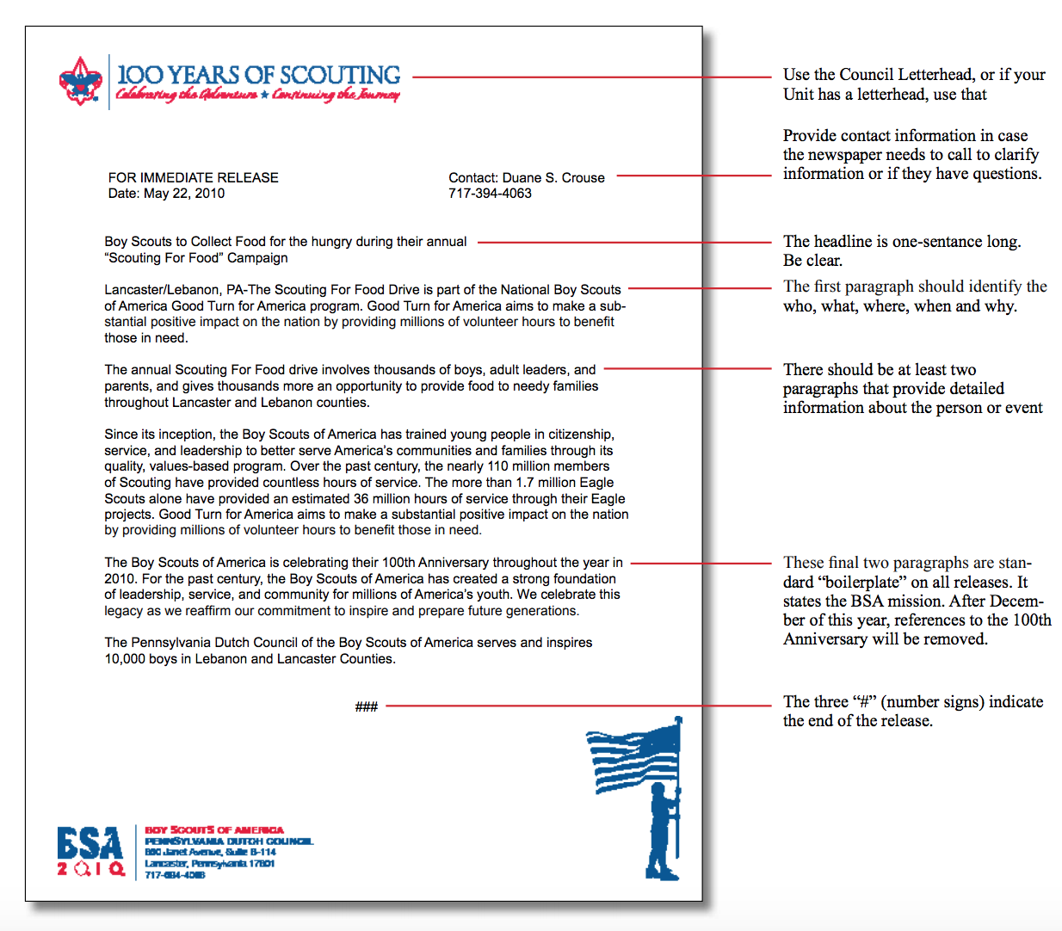

FOR IMMEDIATE RELEASE
Town Name, Unit Number, Location
Date: DAY, MONTH, YEAR (date on which the press release will be sent to the media)

For more information, contact:
Your Name
Your Phone Number, Your Email Address

TROOP XXX keeps Scouting going amid COVID-19 pandemic and Stay-at-Home mandate

Brattleboro, VT—While the COVID-19 outbreak continues to affect everyone, including the more than 3,000 youth members of the Green Mountain Council of Boy Scouts of America, Vermont’s Scouts are resilient and dedicated Scouting leaders continue to invest in our youth. By maintaining programming virtually while adhering to youth protection guidelines, units like TOWN NAME’s Troop XXX are moving forward with activities and meetings that instill leadership qualities into and provide advancement opportunities for Scouting’s participating future leaders.

One recent example of successful Scouting during the Stay-at-Home mandate included a virtual campout by more than XX Scouts from Troop XXX. What started with one Scout’s idea to sleep outside in a tent in her own backyard sparked an entire troop movement. The campers met virtually using Zoom to conduct a flag ceremony and standard opening and then sang songs, told jokes, and talked for an hour. Virtually together, they also played games like Scout Bingo, planned a meal, cooked outside, and shared pictures of their meals and campsites. They even called in later for a virtual group campfire!

"This is so fun! I hope we get to do it again!" one of the Scouts proclaimed. After pausing, she added, "I mean, I would rather GO on our backpacking trip... but if we can't!"

To support leadership development among the youth, virtual Troop meetings are also taking place. For example, Troop XXX recently completed a virtual meeting during which older Scouts helped younger Scouts in the Scouts BSA program work on advancement requirements to achieve their Second Class rank.

For more than 100 years, the programs of the Boy Scouts of America have helped build future leaders by combining educational activities and lifelong values with fun and adventure in the outdoors. Green Mountain Council believes that hope rests on preparing young people for life.

For more information on Scouting programs in Vermont, please visit: www.scoutingvermont.org

INCLUDE A PICTURE OF YOUR UNIT AND PROVIDE A CAPTION
(Be sure to have appropriate photo permissions for images including youth. Your unit should ask families if they are okay with using a picture of their child for publicity before releasing the photo).

###

