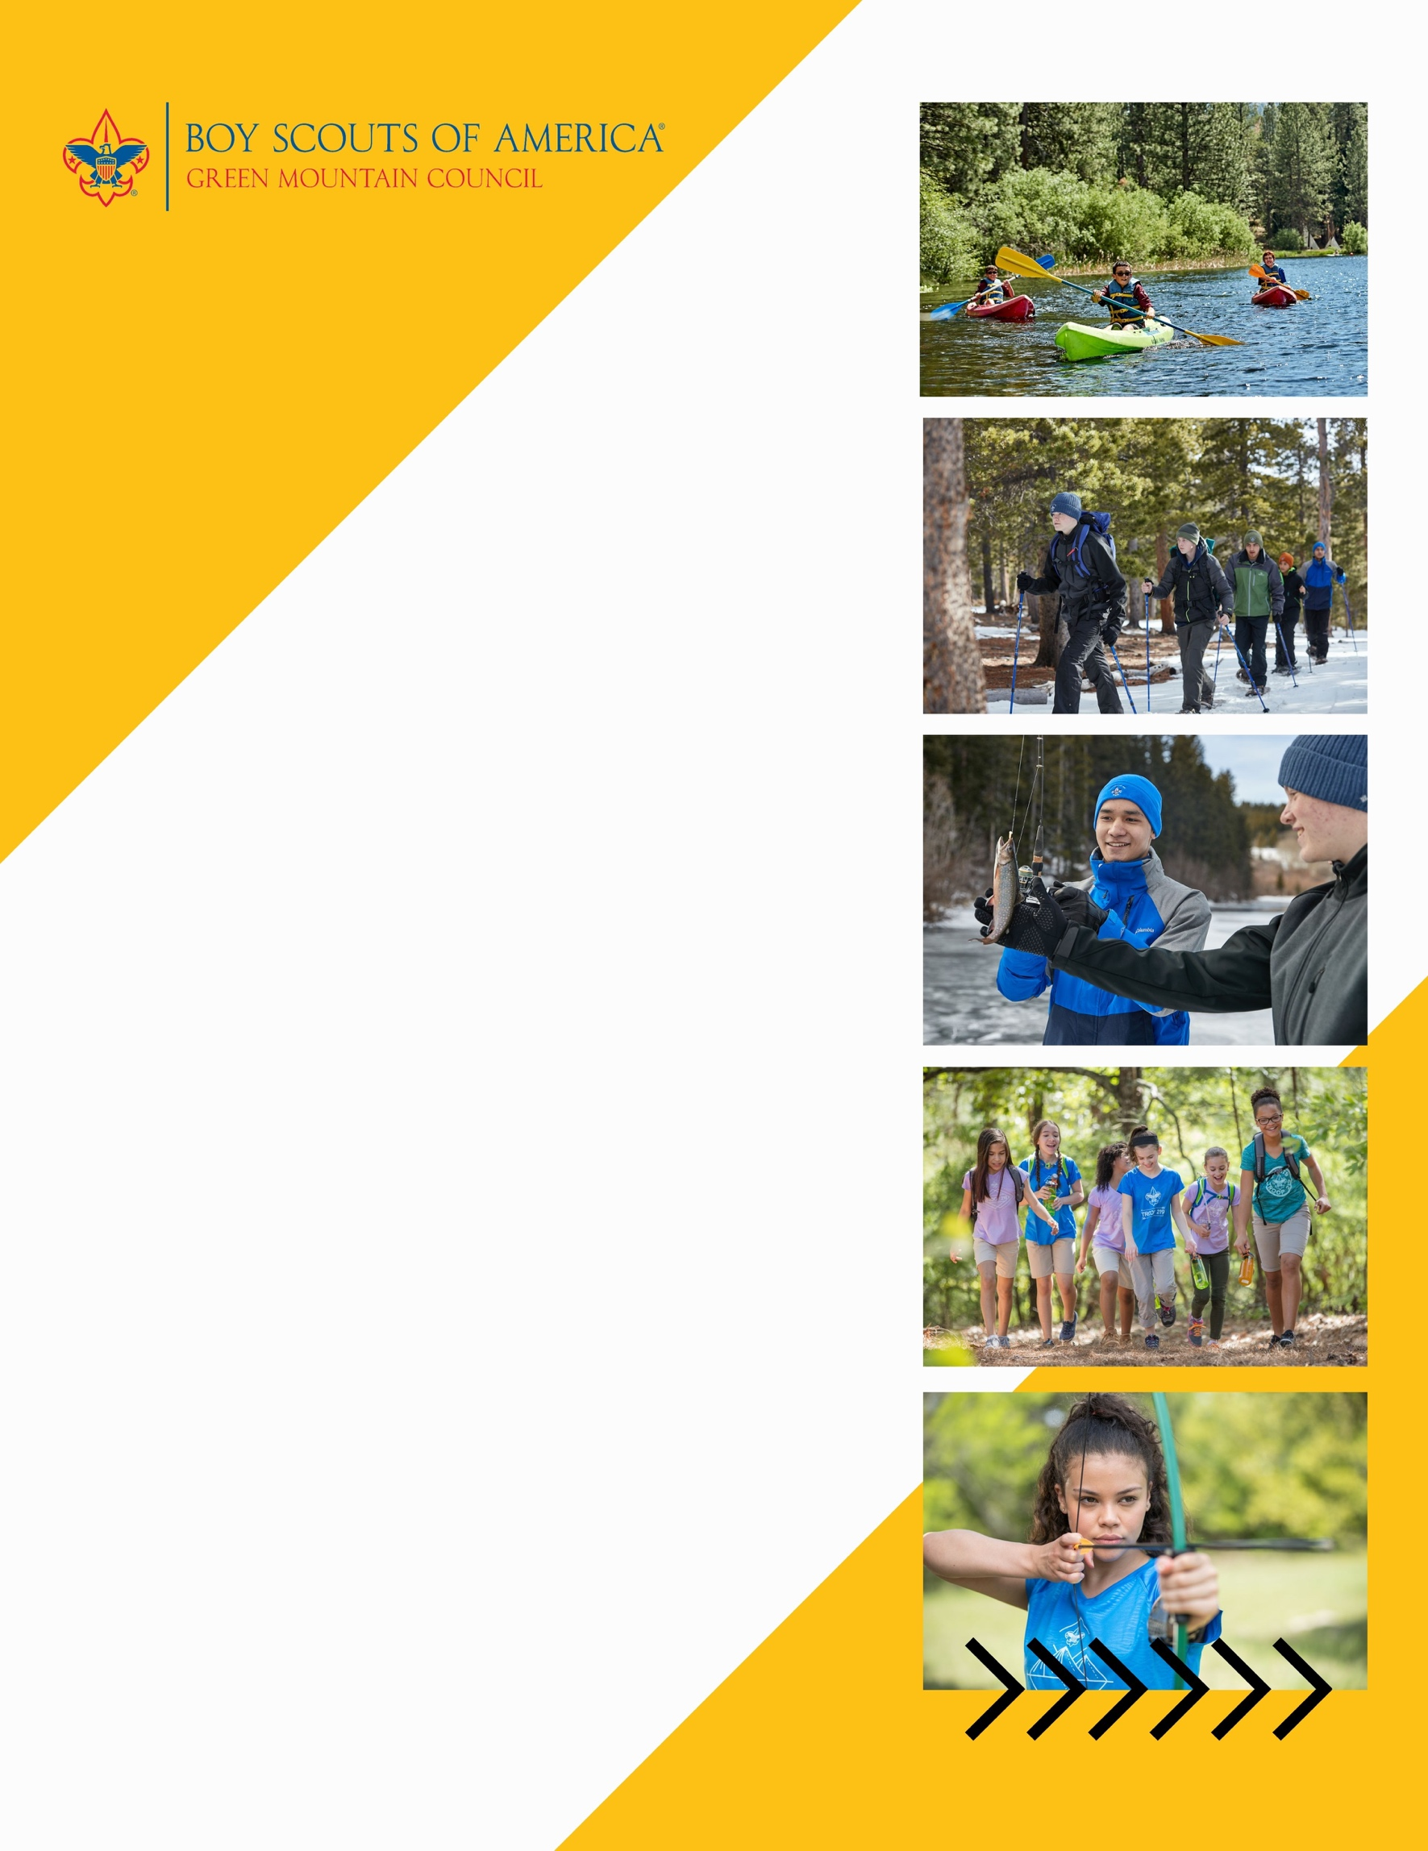

**Woodstock Troop 123**

**invites all youth 11-17 years old**

**to join in the ADVENTURE!**

**…………………………………………**

**Scouts BSA is the Scouting experience for youth in the fifth grade through high school. Service, community engagement and leadership development become increasingly important parts of the program as youth lead their own activities.**

Can’t make it? Lear more about us at scoutingvermont.org

**When:** every Sunday at 5:30PM

**Where:** Barre Congregational Church - 35 Church Street, Barre, VT 05641

**Contact:** Robert Smith

scoutroop123@gmail.com

(802) 345-6029

**Join your Troop at beascout.scouting.org**