101 Great Scout Service Project Ideas for Troops and Packs

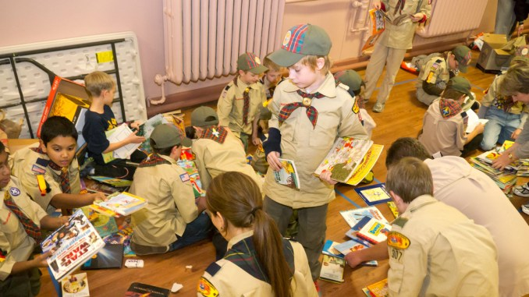
Nothing your Scout unit can do raises community awareness more than a service project.
These good turns are some of our best marketing tools. They send the message that Scouts are here, making life better for others.
But where to start? We have collected 101 Scout service project ideas below. These should get you started, but really anything that fulfills a community need (and follows the BSA’s Guide to Safe Scouting) can count for service hours.
Here’s the list for both Packs and Troops!
Note: While some of these might make great Eagle Scout service projects, most are intended for unit-level service.
- Organize a book and magazine drive, with the collected items going to a daycare, overseas soldiers, a VA medical center or an inner-city school
- Help out a local Cub Scout pack at its pinewood derby, Arrow of Light presentation or by teaching camping or cooking skills
- Improve your local Scout summer camp, perhaps by clearing trails, splitting wood, repairing tents or more
- Volunteer at a district event, running the first-aid station or staffing the Klondike derby
- Participate in Scouting for Food, the annual canned-food drive
- Help at the Scout Show, the council-level event where your volunteer service is always welcome
- Lend a hand at University of Scouting, the training event for volunteers, can always use help
- Go caroling at a local nursing home
- Perform skits or songs at a homeless shelter, nursing home or children’s advocacy center
- Collect gifts and make gift baskets for elderly people with no families
- Prepare and distribute holiday cards (Valentine’s Day, Christmas, etc.) for people without families of their own
- Assist in snow/ice removal for members of the community or businesses that need a hand
- Assist in yard work for members of the community or businesses that need a hand
- Adopt a needy family
- Help agencies cook and serve meals for the homeless
- Make gift boxes to be distributed by a local charity
- Stock shelves at a local food pantry
- Place flags on gravesites for Memorial Day or other special days of remembrance
- Create and deliver thank-you cards to veterans on Veterans Day (or any day)
- Help religious organizations set up religious exhibits or activities
- Deliver, retrieve and dispose of Christmas trees
- Help residents set up or take down Christmas lights
- Repair and paint holiday decorations
- Collect toys for Toys for Tots (or a local equivalent)
- Prepare and serve hot chocolate or apple cider at the annual town tree-lighting ceremony
- Purchase and distribute toys for the children’s hospital near you
- Make stuffed animals, such as a Build-a-Bear, to brighten up a child’s holidays
- Assist with parking cars at a local event (but please follow strict safety protocols!)
- Assemble Easter baskets and distribute to local shelters
- Provide free coffee at rest stops on heavy travel weekends, such as Thanksgiving or Memorial Day
- Help run a fall carnival or pumpkin patch
- Create or help create and run a haunted house
- Assist at alternative trick-or-treat events
- Adopt a town after a disaster
- Assist organizations that provide home maintenance service
- Help paint a school, church or chartered organization
- Clean a Habitat for Humanity house before the family moves in
- Clean a local animal shelter
- Help walk the dogs at the animal shelter
- Perform janitorial duties for your chartered organization
- Repaint fences at government or nonprofit buildings
- Adopt a Highway or road and take care of it
- Take part in a litter cleanup project
- Help beautify city hall
- Clean up and/or help inventory a cemetery
- Clean up and beautify the local community center, campground, park, river or school parking lot
- Clear brush from a fire-prone area
- Improve a town walking trail
- Pick up trash at the chartered organization before or after a meeting (not just the trash you left — check out the entire facility)
- Clean up the shoreline
- Help package medical supplies to be sent to developing countries
- Assist with a blood drive
- Distribute organ donor cards
- Pass out anti-drug literature
- Provide the first-aid station at a district or council event
- Create and distribute first-aid kits to residents in need
- Help children make bicycle safety kits
- Make welcome-home kits for victims of a disaster
- Make bandanas, pillows or other items for cancer patients
- Serve as “victims” for a local first-responders training event
- Adopt a military troop and send them birthday cards and other holiday cards
- Become pen pal with someone serving overseas
- Create video histories of veterans and share the edited results with their families
- Organize a movie night at a VA medical center.
- Send calling cards to servicemen and servicewomen overseas
- Assist in training search and rescue dogs
- Clean and refill bird feeders at the local Audubon Society
- Collect aluminum cans and donate the proceeds to a local charity
- Construct duck houses, owl boxes or birdhouses
- Build an education sandbox for a local nature center
- Build a fence around air conditioners at a local establishment
- Conduct a CPR training event
- Build a handicap ramp at a community location
- As a Boy Scout troop or Venturer crew, offer to cater a pack’s blue and gold banquet
- Run a basketball tournament
- Volunteer at the Special Olympics — water station, handing out medals, etc.
- Construct a soccer field: lines, goals, benches
- Construct bat and helmet racks for your school’s baseball/softball teams
- Build a horseshoe pit at the local park
- Host a dodgeball tournament and donate the proceeds
- Refurbish the press box at a local ballfield
- Serve as volunteer referees or umpires at a sports tournament
- Staff a local run or marathon
- Repair and paint bleachers
- Plant trees
- Hand out voting reminders in the community
- Call residents and encourage them to register to vote
- Conduct a winter coat drive and clean and distribute the coats
- Set up and help run a website or Facebook page for your chartered organization or a local nonprofit
- Perform at a local charity talent show
- Collect unused makeup, perfume and cosmetics for a center for abused women
- Create a poison awareness campaign
- Paint over graffiti (but first check with your city/town government)
- Sponsor a TV blackout event to encourage families to spend time outside
- Host a free camping clinic where you share basic camping skills with residents
- Plant, tend and harvest a vegetable garden and donate what you grow
- Organize a pet show, with a portion of the proceeds going to the winning dogs and the rest going to a local charity
- Design placemats for Meals on Wheels recipients
- Rake leaves for elderly neighbors or your chartered organization
- Lead a game of bingo at a nursing home
- Hold a bike safety rally, where you teach bike skills and inspect the bikes

Ensure a happy holiday parade with these

15 safety tips – for Troops and Packs

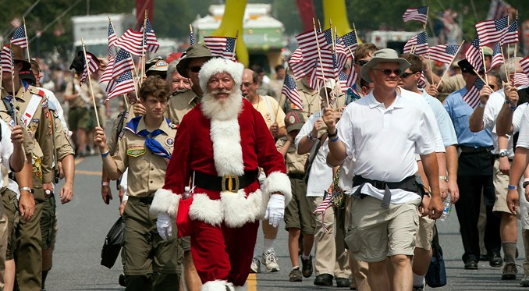
Marching in a holiday parade with your Scouts this year?
Keeping everyone safe should be tops on your wish list. After all, nothing can ruin the holidays quicker than a sprained ankle or broken arm — or worse — a few days before winter break.
Included in the 15 are some tips you might not have known, like this one: Scouts should walk along the route or ride in passenger cars (assuming two-deep leadership).
They may ride on floats, truck beds, trailers or the like, but only if they follow the rules in No. 7 below.
All it takes is one Scout getting injured for you to understand why these rules exist. Is it worth the risk?
Below are the 15 tips:

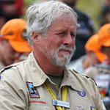

1. Have qualified supervision
Do you have enough adults to supervise Scouts and monitor for hazards along the route?
Many packs and troops use a four-corners approach with adults: two adults at the front — left and right — and two bringing up the rear.

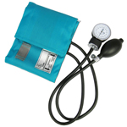

2. Consider physical fitness
How long is the parade route?
Are there hills?
Adults and youth need to be in good enough shape for the length and conditions.

3. Use the buddy system
Before you begin the march, make sure each Scout — and adult! — has a buddy.
That’s especially important in crowded environments.
Parades are typically crowded, and you don’t want a Scout to get lost in the shuffle.

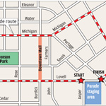

4. Find a safe area
You wouldn’t choose a busy street for a Scout activity, but you don’t get to pick the location of a parade.
Parades can bring risks that might not ordinarily be present:
- Moving vehicles and machinery
- Animals
- Firearms or fireworks
- Hazardous weather
- Large or unruly crowds
- Potential for thrown objects

5. Check vehicles used to transport Scouts
Any vehicle used for transporting passengers should be equipped with a secure passenger compartment and approved safety belts.
And don’t put more people in a passenger vehicle than it’s designed to hold.
See No. 7, below, for more on Scouts and parade vehicles.

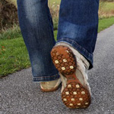

6. Bring personal safety equipment
Dress for the weather, and bring the following:
- First aid kit (one or two per unit should suffice)
- Rain gear
- Good walking shoes
- Water bottle
- Sunblock
- Insect repellant

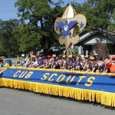

7. Follow proper safety procedures
- Allow adequate space between marchers and any vehicles
- Designate a lookout to watch out for vehicles and other hazards
- Take head counts before, during and after the parade
The BSA rule prohibiting the transportation of passengers in the backs of trucks or on trailers may be tempered for parade floats or hayrides, provided that the following points are strictly followed to prevent injuries:
- Transportation to and from the parade or hayride site is not allowed on the truck or trailer.
- Those persons riding, whether seated or standing, must be able to hold on to something stationary.
- Legs should not hang over the side.
- Flashing lights must illuminate a vehicle used for a hayride after dark, or the vehicle must be followed by a vehicle with flashing lights.

8. Consider the abilities of younger and older members
If the forecast calls for unseasonably warm or cold weather where you live, don’t be afraid to suggest that your younger Cub Scouts or older adults find a seat on the sidelines.
Perhaps they could find a better way to participate that’s suited to them.
Better safe than sorry.

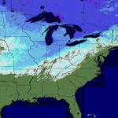

9. Watch the weather
Don’t let a blizzard, high winds or rain make your parade dangerous.
Check the forecast several days out and daily as the parade approaches.
The best outcome in weather emergencies is to avoid them altogether.

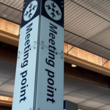

10. Plan ahead
Do you have all of your permission slips?
Did you determine a meeting spot for before and after the parade?
Did you distribute maps and emergency cellphone numbers to the adults?
Hold a pre-parade meeting with adult leaders where you discuss these items, consider severe-weather locations and discuss the location of a support vehicle nearby.

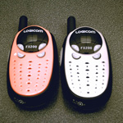

11. Secure a communication plan
Cellphones or two-way radios can keep everyone on the same page.
You can use them in emergencies, of course, but also to tell parents and families when you’re nearing their spot along the parade route.
If you’re using cellphones, make sure you have numbers pre-programmed into your phone. With radios, find an open channel and stick to it.

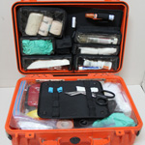

12. Bring a first aid kit
Have first aid supplies handy.
Have trained adults who know first aid.
Find out what resources will be available at the parade, where they will be located and how to contact them if needed.

13. Follow applicable laws
Know and follow all parade rules and regulations.
Most community parades have rules that they distribute to all participants.
Be sure to read them carefully.

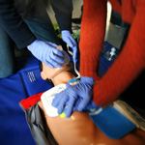

14. Bring a CPR-trained adult
Will there be firemen, EMT professionals and CPR-trained police officers all along the parade route?
Probably.
Should you have a CPR-trained adult with your group anyway?
Absolutely.

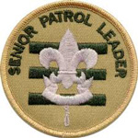

15. Promote discipline
An essential part of parade safety is discipline. That means reminding Scouts that marching in the parade is a privilege.
They’re representing the entire Scouting organization to the community.
If you’re a Cub Scout pack, you can have that talk with the boys. If you’re a troop, ask your senior patrol leader to lead the talk.

