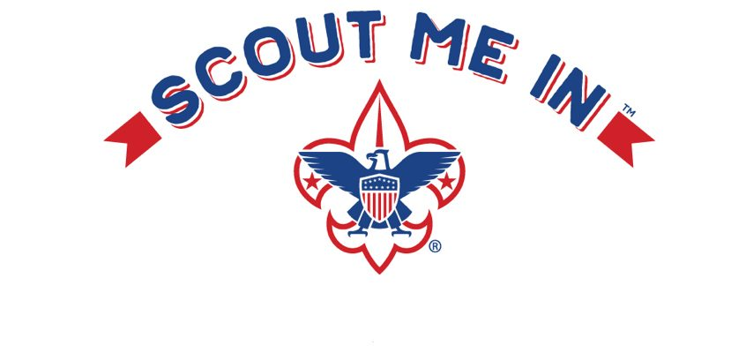
Scouts BSA Parent Guide
Preparing Vermont’s youth for life.

Your Unit Information:

Troop Number: …………………………………………………………………………….…..

Troop Meeting Location, Date and Time: ………………………………………………..

……………………………………………………………………………………………………

Scoutmaster Name and Contact information: …………………………………………

……………………………………………………………………………………………………

Troop website and/or Facebook group: ………………………………………..……….

My Troop's Dues and Registration fees are: ………………………………………..……

Troop Committee Meetings are held on a periodic basis for the adult leadership to discuss the progress of the Troop and the Scouts in the Troop. The meetings are open to every parent of a registered Scout within the Troop.

Council Contact Information:
Physical Address:
838 US Route 2
Waterbury, VT 05676

Mailing Address:
PO Box 557
Waterbury, VT 05676

Phone: 802-244-5189
Toll Free: 800-704-3089
Website: www.Scoutingvermont.org
Subscribe to our Newsletter: http://eepurl.com/hedwBb
Facebook: Green Mountain Council, Boy Scouts of America

Welcome to Scouting!
The purpose of this pamphlet is to explain the operation of our Troop, so the new Scout and his or her family can quickly become involved. If you have additional questions or comments, please notify the Scoutmaster or the Troop Committee.

Scouting Philosophy
Scouts BSA is the traditional Scouting experience for youth in who are 11 to 18 years old. Service, community engagement, and leadership development become increasingly important parts of the program as youth lead their own activities and work their way toward earning Scouting’s highest rank, Eagle Scout.

Scouting's Foundation
The mission of the Boy Scouts of America is to prepare young people to make ethical and moral choices by instilling in them the values of the Scout Oath and Law.

Scout Oath  On my honor, I will do my best, to do my duty to God and my country, to help other people at all times, and to obey the Scout Law. | Scout Law  A Scout is:  Trustworthy Obedient  Loyal Cheerful  Helpful Thrifty  Friendly Brave  Courteous Clean  Kind Reverent

How Scouts BSA Works

Scouts BSA Activities
A Troop has several different types of activities and is busy all year round.

There are regular Troop meetings which are normally held at Location. A typical meeting will include an opening ceremony, group activities with the whole Troop as well as smaller group or Patrol meetings, and a closing ceremony. Depending on the meeting, the activities might include teaching and learning skills; planning for an upcoming camping trip, hike, or other adventure; performing a service project; or playing fun games.

Troops have different camping and other adventure opportunities. There are weekend camping trips with just the Troop or Patrol. Canoeing, hiking, or bike trips are also common. In the Fall and Spring there are camping events with many Troops called Camporees where the Troops will compete at different activities and games. During the summer, Troops attend a week-long summer camp where many Scout skills are taught along with activities such as swimming, boating, and shooting sports.

Scouts BSA also offers high adventure opportunities such as backpacking trips in the Southwest at Philmont Scout Ranch, sailing and scuba at the Florida Seabase, or backcountry canoeing at Minnesota’s Northern Tier High Adventure Base. Every four years, Scouts from all over the US gather at the Summit Bechtel Scout Reservation in West Virginia for the National Jamboree, which is two fun-filled weeks of activities including mountain biking, white water rafting, zip lines, shooting sports, STEM activities, and much more. For even more adventure, there are World Jamborees which are like the National Jamboree, but in different countries with Scouts from all around the world!

The Troop is Youth Led
A Scouts BSA Troop is led by the youth. The adult leaders provide mentoring and guidance to the youth leaders. As the youth may be new and inexperienced leaders, not all activities will go as planned. Scouts BSA provides a safe environment for youth to fail and in the process learn and grow.

The Troop is Sponsored by a Chartering Organization
- Charter organizations can include schools, parent associations, religious organizations, service clubs, or other groups interested in youth.
- The charter organization approves leaders, provides a meeting place, and operates the Troop within the guidelines and policies of the charter organization and the Boy Scouts of America.
- The charter organization selects a Chartered Organization Representative who serves as a liaison between the Troop and the organization. The Chartered Organization Representative approves all adult leaders in the Troop.

Each Troop is Part of a District and Council
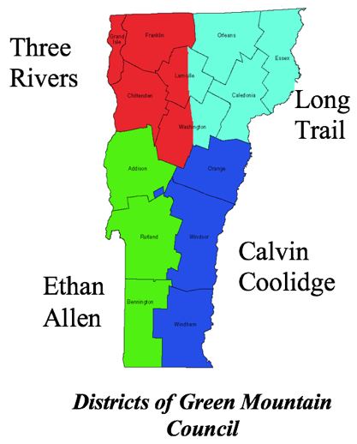
- Councils and Districts are geographically based.
- Our Council, the Green Mountain Council, consists of all Vermont's BSA Scouting units.
- The Green Mountain Council is divided into 4 geographic areas called Districts.
- District Committees, made up of volunteers, provide support to and organize events for the units in their District.
- The Council leadership includes both paid staff and volunteers who offer training, operate the Scout Shop in Waterbury, maintain and manage the Council's two residential camps, and more to support Vermont's BSA units.

Troop Information Distribution
Web page or Facebook if any
While Scouts usually hear details of our events at meetings, this important information is not always passed along to parents. Our Troop website at www.Troop123.org is a great way for you, our parents, to stay informed about our busy Troop and become involved in our activities.

Internet Electronic Mail (E-Mail) (explain to the parent how you will communicate with them)
We will send you an e-mail newsletter, usually with the newest agenda attached, if you provide us with your e-mail address. You may communicate with the Scoutmaster or other Scout leaders over the Internet, however if a quick answer is needed, you probably should call Leader Name at Leader Phone Number.

Supplies

Handbook
Each Scout has their own Handbook. These contain the information your daughter or son will need for the coming years and contains a record of their completed advancement activities. They are available at the Scout Shop in Waterbury.

Uniform (edit for your Troop)
The uniform is an important part of the program. Troop 123 has two uniforms. The Class "A" uniform and the Class “B” uniform.

The Class “A” is the formal uniform consisting of:
- Scout shirt (choice of long or short sleeved)
- Scout shorts or pants
- Scout belt, hat, and neckerchief
The Class "B" is an informal uniform consisting of:
- Scout T-shirt
- Bluejeans or solid color pants or shorts

The Class “A” uniform is normally worn to all activities such as meetings, fundraisers, award ceremonies, district or council events. The Class “B” uniform may be worn during more active activities or when directed by the Troop leadership. When in Class “A” uniform, the shirt will be tucked in and only official insignia and patches may be affixed to the uniform.

There are some patches you'll need to put on the uniform shirt. They include the World Scouting Crest (shown to the left), the Council patch (below) and your Troop's numbers. The staff at the Scout Shop can help you get what you need. Where to put the patches is shown in the inside cover of all Scout Handbooks.
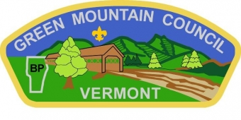

The Green Mountain Council Scout Shop is located in the Council Service Center at 838 US-2, Waterbury, VT 05676. You may visit the Scout Shop in person or if this isn't possible, give them a call and they'll ship your order. For directions, business hours, and a current price list see the shop's website at Scoutingvermont.org/Scout-shop or call (802) 244-5189 or toll-free at 800-704-3089.

Cost
The cost for joining a Scout Troop includes:
- a National BSA registration fee
- a local Council program fee
- an optional subscription to Scout Life magazine
- Troop dues (if any)
Some Troops charge these items individually, while other Troop combine them into a single registration fee. We want your daughter or son to be able to participate in Scouting, and there are resources and options available to assist if the cost is an issue. To learn more about the options available in your Troop, talk with your Troop's Scoutmaster or Troop Committee Chair.

Different activities will have different costs and the cost share between the Troop and parents can vary. Scouts who are unable to attend Green Mountain Council Resident Summer Camp due to financial reasons can apply for a Green Mountain Council Scholarship (Campership). For the more expensive high adventures such as the National Jamboree, there are special fundraising opportunities which can help the Scout pay their own way.

Fundraising
Dues often cover only a portion of an active Troop's expenses. Most Troops conduct at least one fundraising activity during the program year. Beyond helping the Troop financially, fundraisers provide Scouts with the opportunity to earn their own way and be invested in their Troop.

A very common fundraising activity in Scouting is the Annual Popcorn Sale. Most units choose to sell popcorn in the Fall, but Green Mountain Council also organizes a sale in the Spring. Troops may also organize other fundraising activities.

Youth Leadership
Scouts are organized into smaller groups called Patrols, which elect their own youth leadership. The Patrol’s Leader is responsible for its participation in all activities. Ultimately, the Patrol Leader is also responsible for advancement help, task assignment, information dissemination, and leading his or her Patrol in the Scouting method.

The highest youth leader position is the Senior Patrol Leader, or SPL. The SPL runs the Troop activities, with the help of his or her Patrol Leaders and guidance of the Scoutmaster. The Patrol Leaders and Assistants have a key role in helping the SPL and adult leaders accomplish the goals of the Troop.

In addition to the SPL and Patrol leaders, there are many opportunities for youth to be in supporting leadership roles including Assistant SPL, Assistant Patrol Leader, Scribe, Quartermaster, Webmaster, Junior Assistant Scoutmaster, and many more.

Advancement

The Process
The Boy Scouts of America’s advancement program is designed to encourage Scouts to participate in a progressive series of learning experiences. The program also provides a specific means of measuring and recognizing achievement in these experiences. There are four steps that a Scout must go through to advance.

A. Learning by Doing
A Scout practices the skill, participates in an activity, and completes the assignment with his Patrol, counselor, or through independent study.

B. Being Tested
The Scout is tested on the requirements he has completed. If the Scout is completing a skill requirement, another Scout, such as the Patrol Leader or SPL, may do the testing. Testing may also be done by the Scoutmaster or Assistant Scoutmaster. In the case of merit badges, the merit badge counselor is responsible for determining whether the Scout has satisfied the requirements. (Merit badges require independent study and introduce the Scout to specialized subjects that broaden his knowledge and interests.) The Boy Scout Handbook contains a listing of all requirements for advancement in rank and a record of the Scout's progress.

C. Participating in a Scoutmaster Conference
When a Scout has completed all requirements for advancement in rank, he meets with the Scoutmaster for a conference. This conference is designed to involve the Scout in a review of his progress to date. Here the Scout and Scoutmaster work together in setting goals for further development. Thus, the Scoutmaster conference is used mainly to review and set goals.

D. Appearing before a Board of Review
As a final step toward advancement, the Scout goes before a Board of Review, which is a panel of experienced adult Scouters. The Board of Review has three objectives: to determine the extent to which the boy has had a positive and effective experience in the Troop, to make certain that all advancement standards have been met, and to encourage further progress. Advancement in rank is not automatic. If the Board feels that the Scout is not ready to advance, they will offer constructive suggestions designed to strengthen perceived areas of weakness.

Merit Badges
Once a Scout has advanced to the rank of First Class, Merit Badges become the main advancement tool. Scouts can learn about sports, crafts, science, trades, business, citizenship, and future careers as they earn merit badges. There are more than 135 merit badges. Some are required for rank advancement; most are elective.

Adult Leadership
The Scoutmaster is the adult leader responsible for the image and program of the Troop. The Scoutmaster and his Assistant Scoutmasters work directly with the Scouts. The Scoutmaster can be male or female but must be at least 21 years old. He/she is responsible for day-to-day Troop operations and oversees all meetings and activities.

The Troop Committee is a group of adult registered Scouters who meet to establish Troop policy. The Committee supports the Scoutmaster in the implementation of the various Scout activities that the youth have planned, to insure an interesting, successful, and safe program. It oversees all activities and is the ultimate authority concerning Scout operations. The Troop Committee meetings are businesslike affairs handled in a public meeting format. Parents are welcome to express their views at any time and can register with BSA as a Troop Committee member to have an official vote in Troop decisions.

The Troop Committee Chair, the Scoutmaster, and the Chartered Organization Representative are the key adult leaders of a Troop, and combined make up what is commonly referred to as the Key 3.

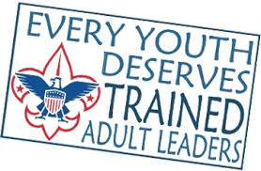
There are many ways to volunteer to assist a Troop. To register as an adult in Scouting, a prospective leader needs to take the online Youth Protection Training (YPT), complete an adult leader application, pay the registration fee, and pass a criminal background check. All registered leaders must take YPT every two years to refresh their knowledge of BSA's policies for the safety and well-being of its members. Two registered adult leaders 21 years of age or over are required at all Scouting activities.

In order to help adults to be effective leaders, the BSA offers a number of training courses through online modules which are publicly available at my.Scouting.org. After creating an account, training is available that is specific to each role in Scouting as well as general skills and other topics.

