Ethan Allen District – Press Release Guidelines and Template

This guide is intended to aid Scouting units throughout the Ethan Allen District to communicate unit activities, achievements, community service, rank advancement, and outings/recruiting activities to your local community. In speaking to many Scouting leaders, most will admit that outside of local communication of Annual Recruiting events or Eagle Scout Projects, many units do not communicate the great work and achievements that local units are completing on a regular basis.

This guide is intended to act as a template to follow for local units to communicate activities to your local communities. Of course parents, family, friends, and neighbors may be aware that youth are involved in Scouting; but when was the last time a teacher, town resident, or community leaders were made aware that an individual unit completed 50 hours of community service collectively over the last 3 months? Or that 12 local youth have completed a combined 28 nights of camping, earned 55 merit badges, or achieved 14 rank advancements? What about communicating an upcoming outing where you may be able to pick up 2 new Scouts if local youth were made aware of it several weeks ahead of time?

The next question for many adult leaders is: Where should my unit send this information in order to communicate this to the community? What should the content include? Is there a template I can use? This guide is intended to help you do just that.

The following pages are intended to act as an outline that unit adults can follow, a proposed schedule, and some content ideas that act as a best practice outline for units to communicate the great work they are doing in their communities. The communication areas located within this guide provides information by county for Local News publication contacts and preferred social media outlets that can be used to highlight why Scouting is important, what your unit means to the youth that are a part of it, and the communities you serve.

The District Committee is hopeful that this will help spread awareness of your program, and to put the attention of Scouting where it belongs, on the Scouts that are following the Scout Oath and Law; and the Unit Leaders & Chartering Organizations that are overseeing these programs.

Thank you for all you do with local Scouting.

Sincerely,
Shawn Therrien
Ethan Allen District Committee Chair

Press Release Content Ideas:
As with any Scouting activity, safety and Youth Protection should be a key focus. Staying true to the commitment of the BSA to be an advocate for youth and to keep children and their privacy safe, should always be at the forefront of any considerations where print or social media usage is concerned.
All posts to social or print media should only be performed by a Scout leader and should be monitored. Scouts may post follow up comments on social media based on events, but all communications should only originate from a Leader. Content must be Scout appropriate and follow the YPT, Guide to Safe Scouting, and the Internet Safety pledge as outlined I the BSA Cyber Chip for Scouts.
Units should plan on including information within your press release that includes:
- Recent Scouting Activities
- Details about Rank Advancement
- Skill Awards or Merit Badges
- Community Service Activities
- Camping, Hiking, Boating, or Outing Details
- Upcoming Events (keep it generic, do not publish specific days, times, or locations of activities unless approved by the unit leadership. Contact information for interested individuals should be directed to a designated leader).

Items you should NOT include:
- Do not use full names or photos of Scouts or Scouters without proper release forms in place (see below).
- Do not include addresses, phone numbers, or email information for any youth. Any inquires or contacts to the unit should be directed to www.beascout.org or to a designated Scout Leader directly.
- Any negative comments about an individual, group, organization, religion, or experience has no place in these communications and is in direct violation of the Scout Oath, Law, and the BSA’s position on inclusion and diversity.
- Do not show favoritism towards any individual, organization, business, or activity. Communications should be factual, succinct, and to the point.

Suggested Items to include on Press Releases beyond Summary’s and Statistics
In addition to sighting details on items that have recently happened, communications may include up-coming items that the community may want to know about. This can include unit specific items that you have planned on your calendar, fundraisers, recruiting events, celebrations, or may include details on events that are reoccurring by month or time of the year.

Reoccurring Scout Event Calendar by Month:
January: Polar Bear (Winter Camping)
February: Winter Trek/Klondike Derby/Eagle Scout Appreciation
March: Cub Scout to Troop Cross Overs, Pinewood Derby
April: Blue & Gold Banquets/Awards
May: Green Up Day/Spring Camporees/OA Ordeal Weekend/Beaver Day/Memorial Day Parades
June: Beaver Day/Webelo Woods
July: Summer Camp
August: NYLT/Woodbadge/District Kickoff
September: Fall Ordeal/Popcorn Sales/Fall Camporee
October: Fall Fellowship/Beaver Day/Haunted Harvest Fest
November: Veteran’s Day Events
December: Christmas Tree/Wreath Sales

Press Release Template Overview:

Below, please see a sample press release explained. On the following pages you will find a Microsoft Word template that you can use to draft your own targeted press release for your unit.

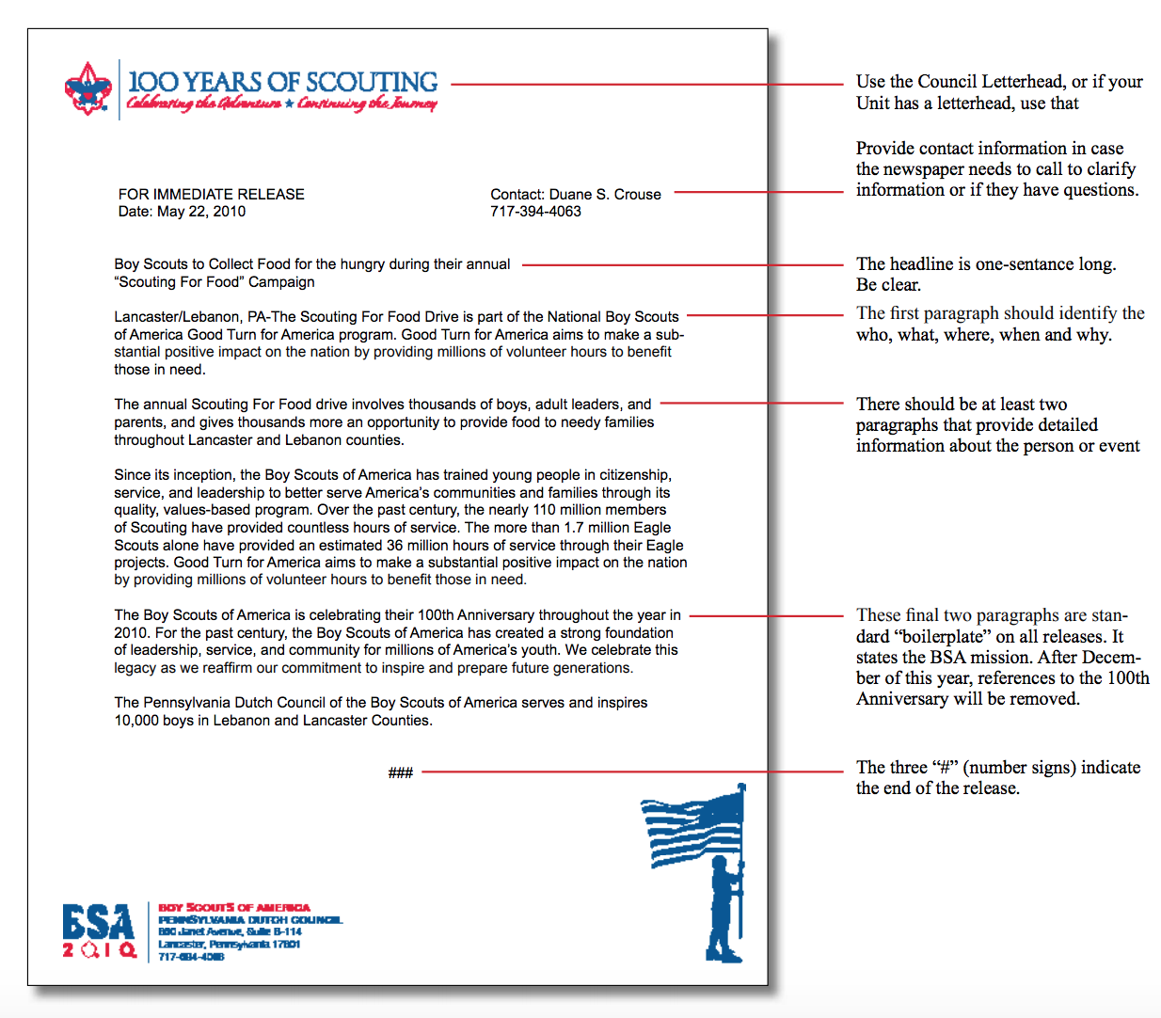

Press Release Template:
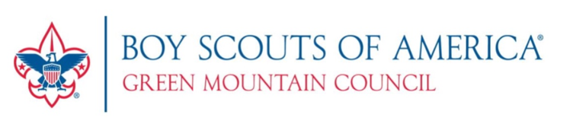

FOR IMMEDIATE RELEASE For more information, contact:
Town Name, Unit Number, Location Your Name
Date: DAY, MONTH, YEAR Phone Number, Your Email Address
(press release sent to media)

TROOP/PACK XXX keeps Scouting going amid COVID-19 pandemic and Stay-at-Home mandate

Brattleboro, VT—While the COVID-19 outbreak continues to affect everyone, including the more than 3,000 youth members of the Green Mountain Council of Boy Scouts of America, Vermont’s Scouts are resilient and dedicated Scouting leaders continue to invest in our youth. By maintaining programming virtually while adhering to youth protection guidelines, units like TOWN NAME’s Troop/Pack XXX are moving forward with activities and meetings that instill leadership qualities into and provide advancement opportunities for Scouting’s participating future leaders.

One recent example of successful Scouting during the Stay-at-Home mandate included a virtual campout by more than XX Scouts from Troop XXX. What started with one Scout’s idea to sleep outside in a tent in her own backyard sparked an entire troop movement. The campers met virtually using Zoom to conduct a flag ceremony and standard opening and then sang songs, told jokes, and talked for an hour. Virtually together, they also played games like Scout Bingo, planned a meal, cooked outside, and shared pictures of their meals and campsites. They even called in later for a virtual group campfire!

"This is so fun! I hope we get to do it again!" one of the Scouts proclaimed. After pausing, she added, "I mean, I would rather GO on our backpacking trip... but if we can't!"

To support leadership development among the youth, virtual Troop meetings are also taking place. For example, Troop XXX recently completed a virtual meeting during which older Scouts helped younger Scouts in the Scouts BSA program work on advancement requirements to achieve their Second Class rank.

For more than 100 years, the programs of the Boy Scouts of America have helped build future leaders by combining educational activities and lifelong values with fun and adventure in the outdoors. Green Mountain Council believes that hope rests on preparing young people for life.

For more information on Scouting programs in Vermont, please visit: www.scoutingvermont.org

INCLUDE A PICTURE OF YOUR UNIT AND PROVIDE A CAPTION

Note: (Be sure to have appropriate photo permissions for images including youth. Your unit should ask families if they are okay with using a picture of their child for publicity before releasing the photo).

###

See the Talent Release Form here: https://filestore.scouting.org/filestore/marketing/doc/talent.doc

Locations to Send/Communicate Press Releases:

EA District Newspaper Publications:
- Addison Independent – email to: email to: news@addisonindependent.com
- Rutland Herald/Times Argus – email to: news@rutlandherald.com
- Bennington Banner – email to: news@benningtonbanner.com
- Manchester Journal – email to: news@manchesterjournal.com
- Brandon Reporter – email to: news@brandonreporter.com
- Lakeside News & The Rutland Sun – email to: roy@lakesidenews.org
- Vermont News Guide – upload press release: https://vermontnews-guide.com/press-release-submissions/
- Mountain Gazette – email to: mtgazette@earthlink.net

Social Media Publications:
- Facebook – Ethan Allen District Facebook Page: https://www.facebook.com/search/top?q=ethan%20allen%20district
- Front Porch Forum: https://frontporchforum.com/
- Scout Unit Websites

Note: All Social Media posts should adhere to the BSA Social Media Guidelines: https://scoutingwire.org/social-media-guidelines/

